1. npm install express
2. then opening folder in VS (D:\Himanshu\E-Commerce\WebApp)
3. create new file “server.js”
4. write this

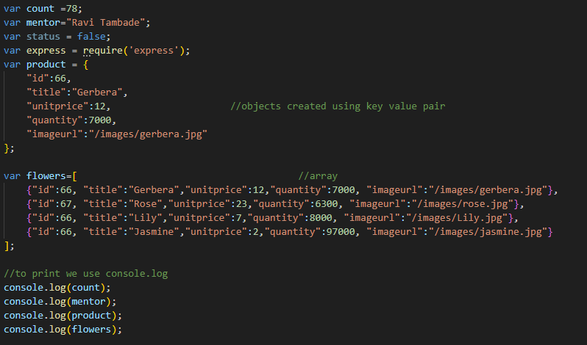

1. to run, in powershell or cmd, write “node server.js”

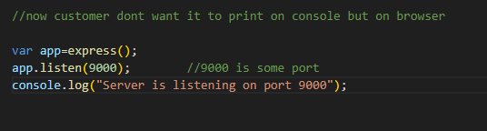

7.

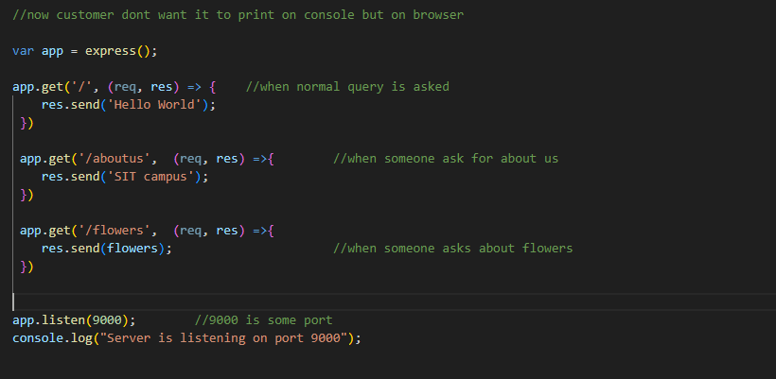

1. Now run
2. We get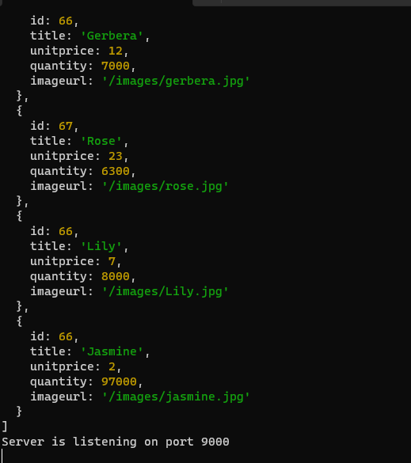
3. And program is still running
4. Now open brower and write localhost:9000
5. 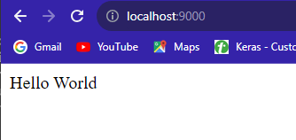
6. If we write localhost:9000/flowers, we get

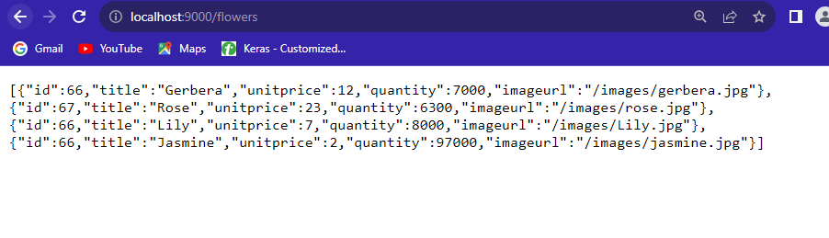

1. 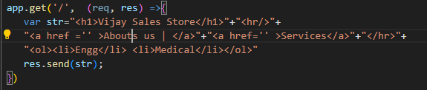
2. This become homepage
3. Output:
4. 